<organization logo>

# **<organization name>**

Program Report

Prepared For

1TREELLION.ORG

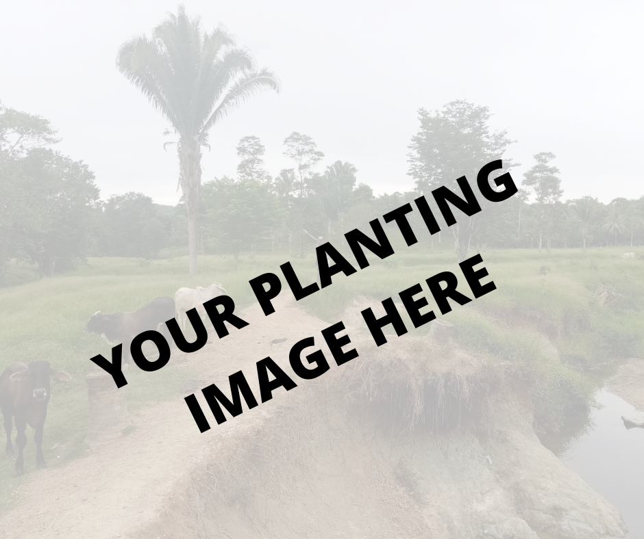

by <organization name> on: <date>

**Grantee**:

**Project title**:

**Project original target**: <number of> trees

**Project planting date:** <DATE>

**Project coordinator:**

**Reporting period:**

**Location of planting:**

* **GPS coordinates of planting:**

**Project description** (general aspects and goals, landscape and territory attributes):

* <PLEASE DESCRIBE >
* 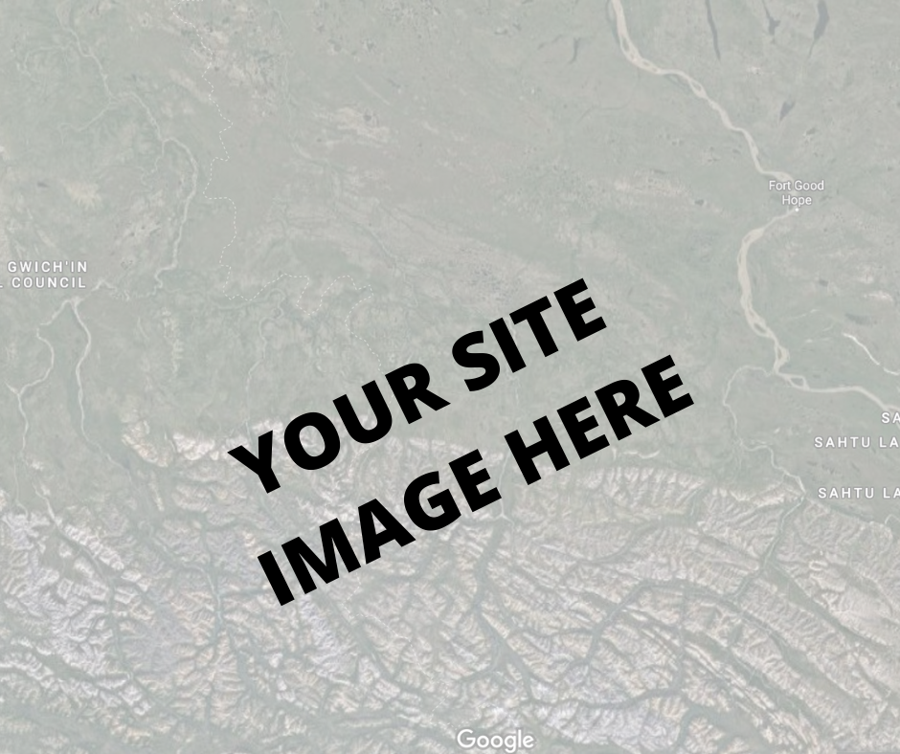
* <PLEASE DESCRIBE >

**Project ongoing status**

* **Species of trees planted**:
* Number of trees planted to date
* Coverage area - of planting site, in hectares
* **Planting method (Agroforestry systems or total planting of seedlings)**
* **Survival rate (Describe counting method, if sampling or census. If sampling, consider at least 20% of the planted area)**: %
* **Trees growth progress:**
  + **Measurements**
    - **Species richness: Count the number of different forest species (above 30 cm in height), planted by the project or already existing. Sample 20% of the planted area**
    - **Seedling density: Count the number of seedlings planted in an area corresponding to 20% of the planted area (sampling). Extrapolate the result to one hectare giving the number of seedlings per ha.**
  + **Canopy coverage - please define the technique used to measure**
  + **Soil (If your project aims to also recover degraded soils, please describe progress and improvement levels e.g. presence and/or thickness of litter (leaves and organic matter)**
  + **Water (If your project aims to also recover water quality and availability, for human and/or agricultural use, please describe progress)**

**Future steps**

* Next plantings
* Operational programs
* Other programs
* <anything else relevant>

**Additional information**

*<please include & describe all that is relevant>*

* <Some example wellbeing / community/ water>
* <Related projects>
* <animals / ecosystem restoration>
* <biodiversity measures>
* <livelihood>
* <water supply>
* <educational aspects>
* <nutrition>
* <women and children>

**Socio Economic Aspects**

<Please describe the community’s involvement in this project>

* **Number of people involved in the project (directly and indirectly):**
* **Are women still involved in the project?**

Please explain how many and how

Be specific about each role

* **Are youth involved in the project?**

Please explain how many and how

Be specific about each role

* **The species planted are related to generate food or income for the community involved (directly or indirectly**)?

Please explain and demonstrate improvement (in numbers)

* **Planting Site as a Source of Income**

Please explain if the project enabled any income to the community

Be specific

**Problems & ways of mitigating**

*<please describe any issues in the planting site. Issues can be insects/invaders/community need to harvest/disease/ clear cutting for cattle/ other.*

*List all problems and your plan to solve them*

*If problem was solved please describe how*

*If problem is still relevant please state the plan to overcome it>*

**Risk management**

*<please describe any issues separated by local risk group that could compromise project effectiveness>*

***Climate risks:*** *List local issues of occurrence of extreme events or noticeable changes in recent years.*

***Operational risks:*** *List issues related to labor, anthropic factors of degradation and control measures.*

***Socio-economic risks****: List issues related to local restrictions (civil conflicts, illegal deforestation, financial collapse) and others that may affect the progress of the project.*

***Institutional risks****: List risks related to local governance that may affect the progress of the project.*

**Climate Resilient**

*<have the trees helped in mitigating or adapting climate change? yes/no & how>*

**Photographic report:**

*<please include a wetransfer link to images and videos of the trees and the community involved & effected>*

-link to images to download

-link to videos to download

-Latest google earth image and link demonstrating planting area and coordinates

**Anything else?**

Please share any

**Information about the person filing this report**

Name ______________________

Role ______________________

Email ______________________

Date ______________________