<organization logo>

# **<organization name>**

Program Report

Prepared For

1TREELLION.ORG

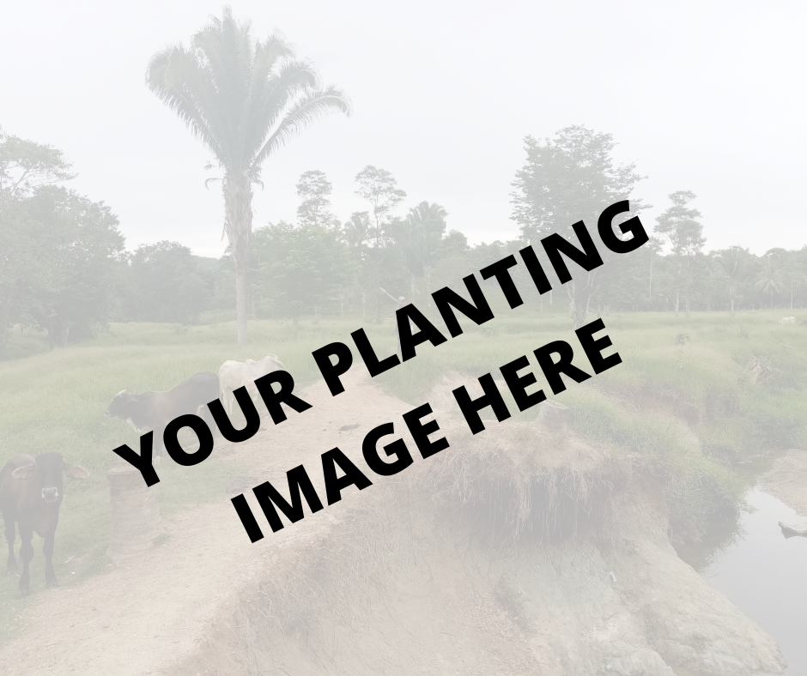

by <organization name> on: <date>

**Grantee**:

**Project title**:

**Project target**: <number of> trees

**Project deadline:** <DATE>

**Project coordinator:**

**Reporting period:**

**Location of planting:** <address>

* **GPS coordinates of planting:**

**Project description** (general aspects and goals, landscape and territory attributes):

* <PLEASE DESCRIBE >
* 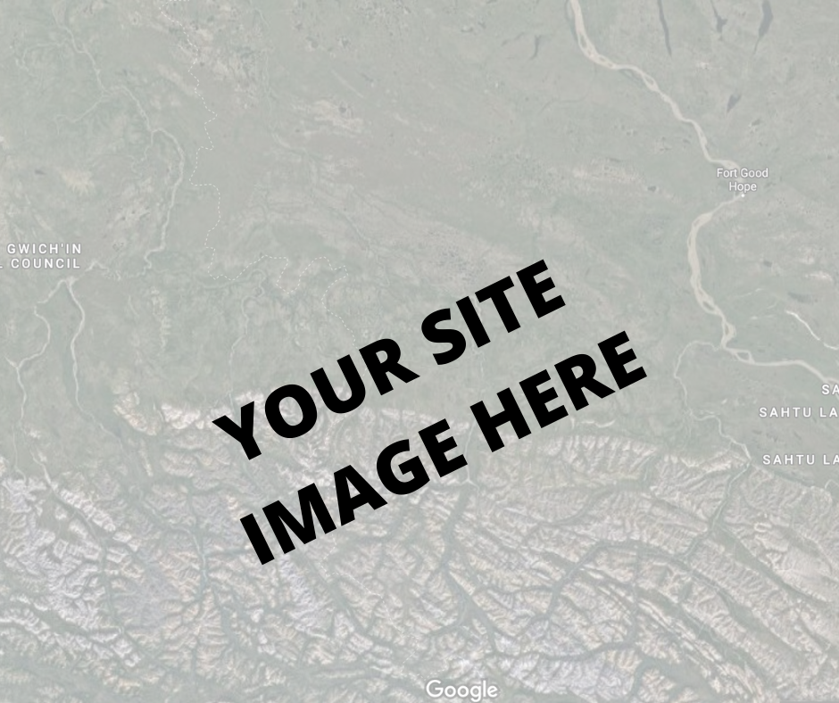
* <PLEASE DESCRIBE >

**Project outcomes**

* **Number of trees planted**:
* **Type of trees planted**:
* **Size of trees**:.
* **Location:**
* **Survival rate**:
* **Trees growth progress:**
  + **Measurements**
  + **Canopy coverage**
  + **Soil (If your project aims to also recover degraded soils, please describe progress and improvement levels)**
  + **Water (If your project aims to also recover water quality and availability, for human and/or agricultural use, please describe progress)**

**Managememt**

* Did your community have any sustainable forest management practices prior to 1treellion's involvement? If so, please tell us more
* Do you have any forest management practices in place now? If so, please tell us more.

**Additional information**

* <Some example wellbeing / community/ water>
* <Related projects>
* <educational aspects>

**Socio-economic aspects**

<Please describe the community’s involvement in this project>

* **Number of people involved in the project (directly and indirectly):**

<Please specify numbers>

* **Are women involved in the project?**

<Yes / no - how many?>

* **Are youth involved in the project?**

<Yes / no - how many?>

* **The species planted are related to generating food or income for the community involved (directly or indirectly**)?

<please list here. This my include food trees or trees use for medicinal or nutritious values>

**Climate Change & Ecological Disasters:**

1. Did your community experience ecological disasters in the past 5 years? If yes, please Select these events
   1. Drought
   2. Heat waves
   3. Floods
   4. Landslides
   5. Wildfire
   6. Hurricanes
   7. Blizzards
   8. Avalanches
   9. Volcanic Eruptions
   10. Other (specify)
2. If your community has experienced ecological disasters in the past 5 years, can you please indicate the consequences of this disasters (if you know the range or number for each ecological disaster it would be great)
   1. People went missing
   2. People died
   3. Jobs losses
   4. Field losses
   5. Other (specify)
3. Did these consequences have an economic loss for the community?
4. Has the direct economic loss attributed to disasters improved since the project started?
5. Has your community adopted and/or implemented disaster risk reduction plans or strategies? Please explain

**Education and awareness:**

1. To what extent has your community improved education and raised awareness for each of the following categories?
   1. (i) Global citizenship education
   2. (ii) Education for sustainable development are mainstreamed in
      1. National education policy
      2. Curricula
      3. Teacher education
      4. Student assessment.
   3. Please provide specific information for those that apply.

**Agriculture & Wildlife:**

1. Did you have sustainable agriculture before the project started? Do you have any now after the project started?
2. Do you have wildlife, do they harm the community, do you have anything to protect them? Do you know people trading or trafficking animals?
3. Have you seen other animals coming because of the project?
4. Have you seen other animals coming because of the project?
5. If yes, please put the range on how many species have returned
   1. 0-5
   2. 5-10
   3. 10-15
   4. 15+
6. Can you please indicate the total agricultural population (# of people) working the land (agriculture) (pre and post project). Who owns the land? Your community works in agriculture, how many are men and women?
7. from the people working in the land, how many of them own the land? (Pre and post project) Is there a plan for them to own land? Has it improved? How many? Types of tenure?

**Water:**

1. In your community do you have running water? How do you collect water?
2. Where does the water waste go? Is there a plan to improve the wastewater systems? How was it before the project and after the project?
3. Do you know if there are water bodies with poor & good ambient water quality? Do you know how many? (Give ranges)

**Employment:**

1. How is the job situation in your community? People are self-employed, work for someone, etc? How is it for women and men?
2. How is the income source and job stability in your community? Has this improved after the project?
3. What was the average household income of your community?

**Additional questions:**

1. What lessons have you learned from the project so far?
2. What do you think are key factors that have made the tree plantation a success?
   1. Advantages
   2. Challenges
3. What do you wish to know more about?
4. What have been noticeable changes before, during, and after the plantation?
5. What worries you about the plantation, and trees? Concerns?
6. Could you please share 1-2 quotes from children, man women on how the project has impacted them and the community

**Photographic report:**-link to images to download

-link to videos to download